LAB #2
FORCES ON A BOOM

Josiah Abel
METC 111

OBJECTIVE: To use the sum of the torques in a hanging boom to mathematically and experimentally determine the tension on a cable keeping the boom arm and a hanging mass suspended.

CONCLUSION: The Measured forces and torques were equivalent to the calculated forces and torques

BACKROUND: Static equilibrium is achieved only when all of the forces and torques add together to equal zero. The system that is set up has four forces acting on it: the force due to gravity, the force from the string, the force from the hanging mass, and the normal force. We also know there are three moments acting on the system: the moment from the string, the moment from the hanging mass and the moment due to gravity. Knowing intuitively that this system is in static equilibrium because it is not moving, we can solve for the tension in the string using the following equation.

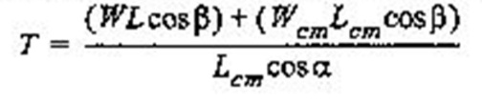
Where W is the weight of the balance arm assembly, L is the length of the balance arm assembly, W_{cm} and L_{cm} are the weight of the balance arm assembly at the center of mass and the length of the balance arm assembly at the center of mass respectively. T is the tension in the string β is the angle between the balance arm and a horizontal line and α is the angle between the string and a line perpendicular to the balance arm.

MATERIALS USED:
Statics board
Pulleys
Thread
Mounted spring scale
Balance arm
Protractors
Mass set and hangers
Pivot

PROCEDURE: On a balance arm that had a ruler on it running from -170mm to 170 mm one protractor was attached at 0mm and the other at 160mm. The pivot was attached at -160mm. This balance arm assembly’s weight was found and recorded. The assembly was attached to the statics board via magnets on the pivot. The spring scale and pulley was mounted above the balance arm assembly. A string was run from the scale around the pulley and tied to the protractor at 0mm. The angles α and β were recorded and the reading on the spring scale was recorded. For the next part of the experiment a hanging mass of 147g was attached to the protractor at 160mm with thread. The angles α and β were recorded and the reading on the spring scale was recorded.
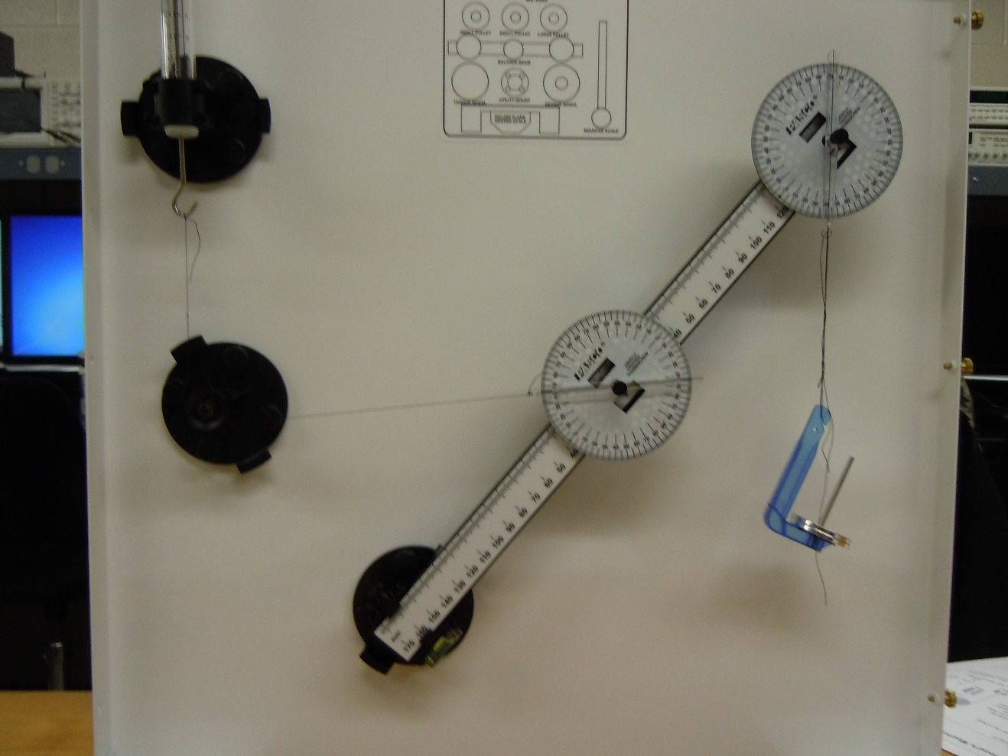
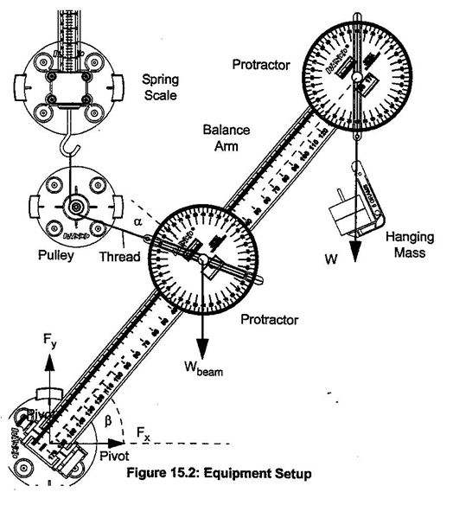

DATA:
 |  |  | Trial 1
Length | Length _{center of mass} | α | β | Weight _{Boom} | Weight _{Mass} | T _{mathematical} | T _{Experimental}
m | m | degrees | degrees | N | N | N | N
0.32 | 0.16 | 60 | 60 | 0.6 | 0 | 0.6 | 0.6

 |  |  | Trial 2
Length | Length _{center of mass} | α | β | Weight _{Boom} | Weight _{Mass} | T _{mathematical} | T _{Experimental}
m | m | degrees | degrees | N | N | N | N
0.32 | 0.16 | 45 | 50 | 0.6 | 0.147 | 0.95 | 0.9

DISSCUSSION: The slight difference in the mathematical and experimental results in trial 2 could be attributed to the accuracy of the measuring scale and not being able to read to hundredths of a newton with verifiable precision.

